TRELLO SCRENSHOTS:
1 ) Project title : Floppy Bird Game:
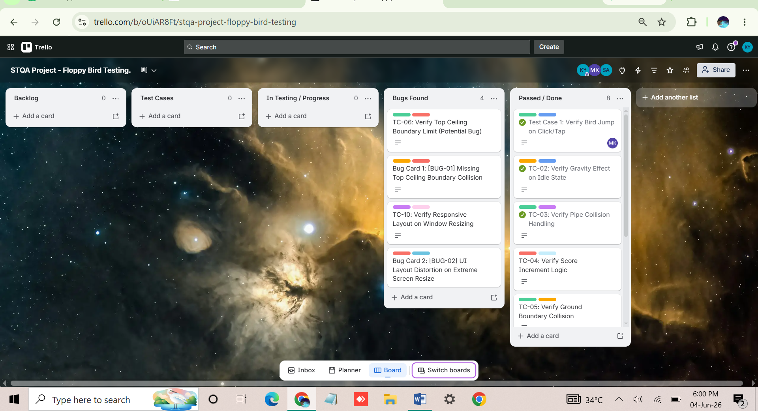
Link: https://trello.com/b/oUiAR8Ft/stqa-project-floppy-bird-testing

2 ) project tiltle: Airline Booking Website Testing
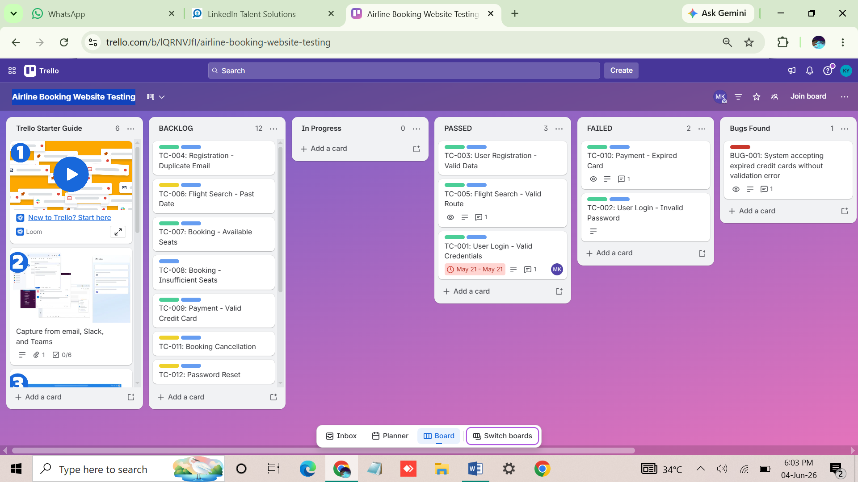
Link: https://trello.com/b/lQRNVJfI/airline-booking-website-testing

Game link: https://nebezb.com/floppybird/

